1. HomePage

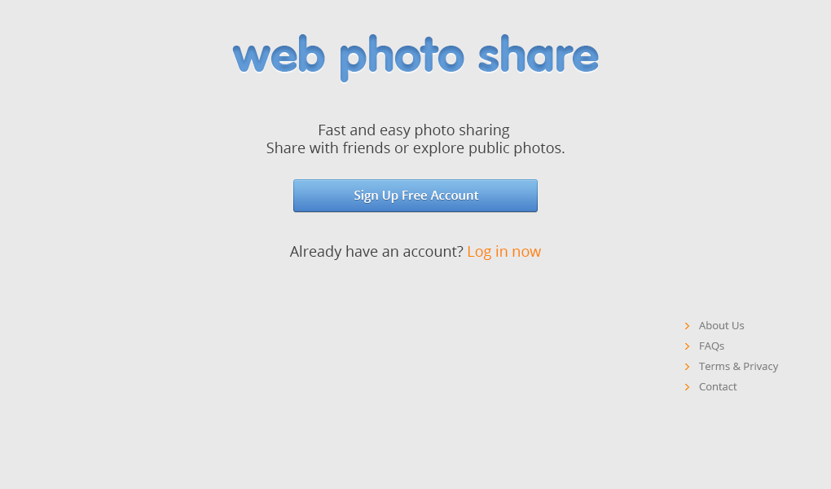

|  |  |  |  |  |  |  |
| --- | --- | --- | --- | --- | --- | --- |
| Administrator & Staff Login | | | | | | |
| No. | Name | Type | Validation | Event | Description | Status |
| 1 | btnregister | Button |  | Click | Sign Up Free Acount | Enable |

1. Login

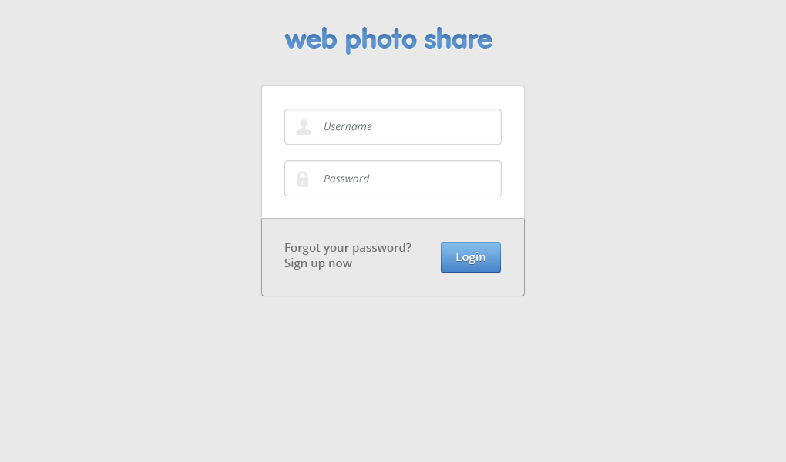

|  |  |  |  |  |  |  |
| --- | --- | --- | --- | --- | --- | --- |
| Administrator & Staff Login | | | | | | |
| No. | Name | Ty pe | Validation | Event | Description | Status |
| 1 | txtUsername | Textbox | Not null |  | Username of User | Enable |
| 2 | txtPassword | Textbox (Mode Password) | Not null |  | Password of User | Enable |
| 3 | btnLogin | Button |  | Click | Process Login Request | Enable |

1. Sign Up

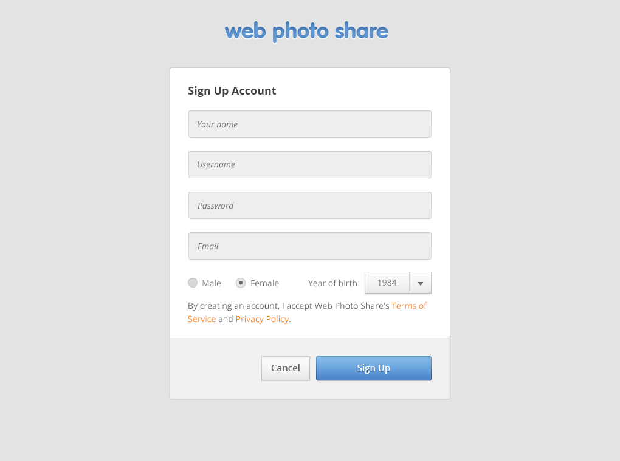

|  |  |  |  |  |  |  |
| --- | --- | --- | --- | --- | --- | --- |
| Administrator & Staff Login | | | | | | |
| No. | Name | Ty pe | Validation | Event | Description | Status |
| 1 | txtYourname | Textbox | Not null |  | Yourname of User | Enable |
| 2 | txtUsername | Textbox | Not null |  | Username of User | Enable |
| 3 | txtPassword | Textbox (Mode Password) | Not null |  | Password of User | Enable |
| 4 | txtEmail | Textbox | Not null |  | Email of User | Enable |
| 5 | radGender | Radio | 1.Male  2.Female |  | Gender of User | Enable |
| 5 | cboYearofbirth | Comboox |  |  | Year of birth | Enable |
| 6 | btnCancel | Button |  | Click | Return to previous page | Enable |
| 7 | btnSignUp | Button |  | Click | Process Login Request | Enable |

1. HomePage

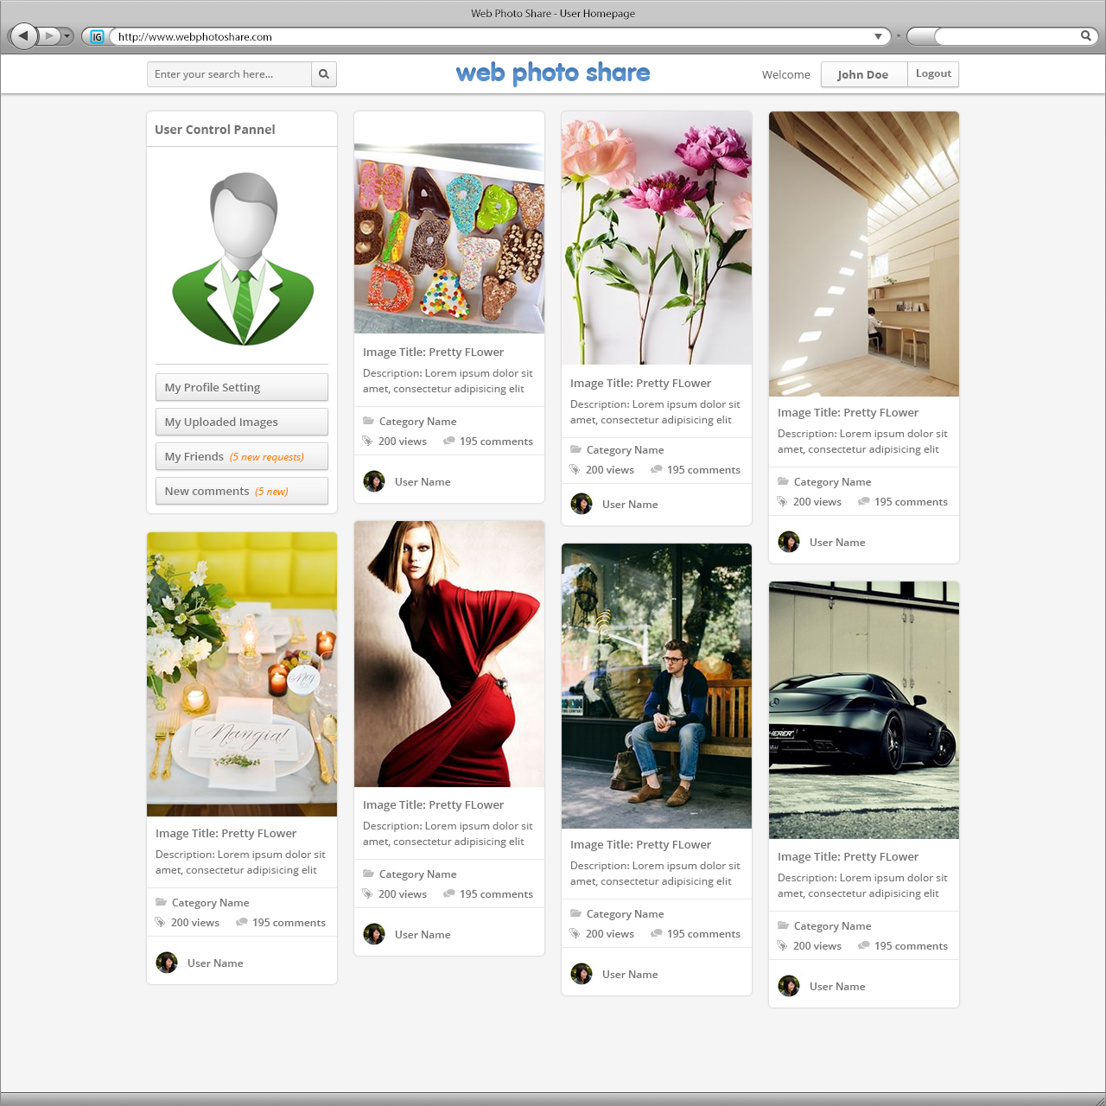

5.User

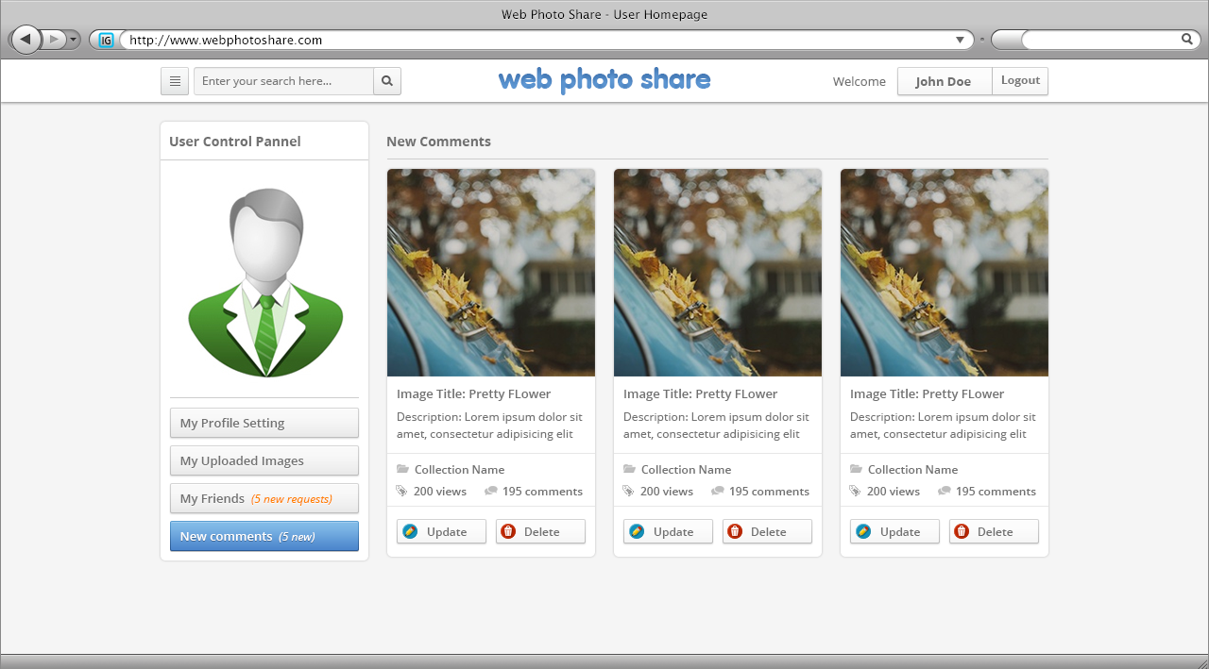

6.Account Setting

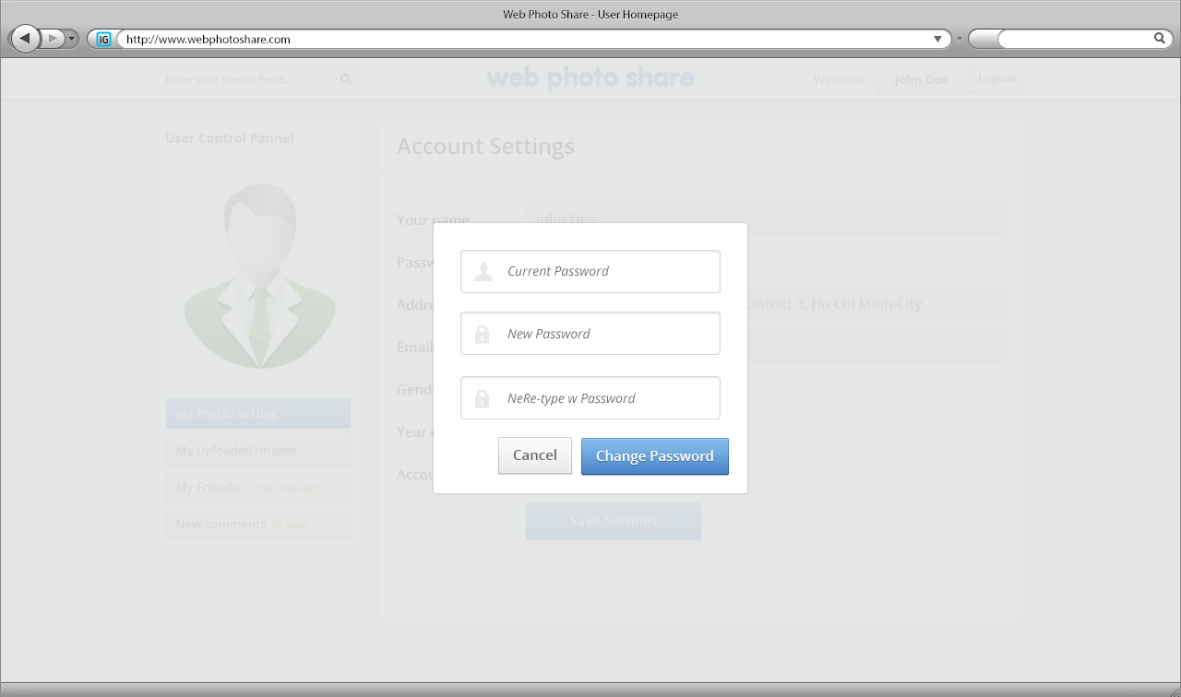

|  |  |  |  |  |  |  |
| --- | --- | --- | --- | --- | --- | --- |
| 1 | txtCurrentPass | Textbox | Not null |  | Password | Enable |
| 2 | txtNewpass | Textbox | Not null |  | password | Enable |
| 3 | txtTypepass | TextBox | notnull |  | password | Enable |
| 4 | btncancel | button |  | Click | Process | Enable |
| 6 | btnChangepass | Button | notnull | Click | Process | Enable |

7.User-Friend

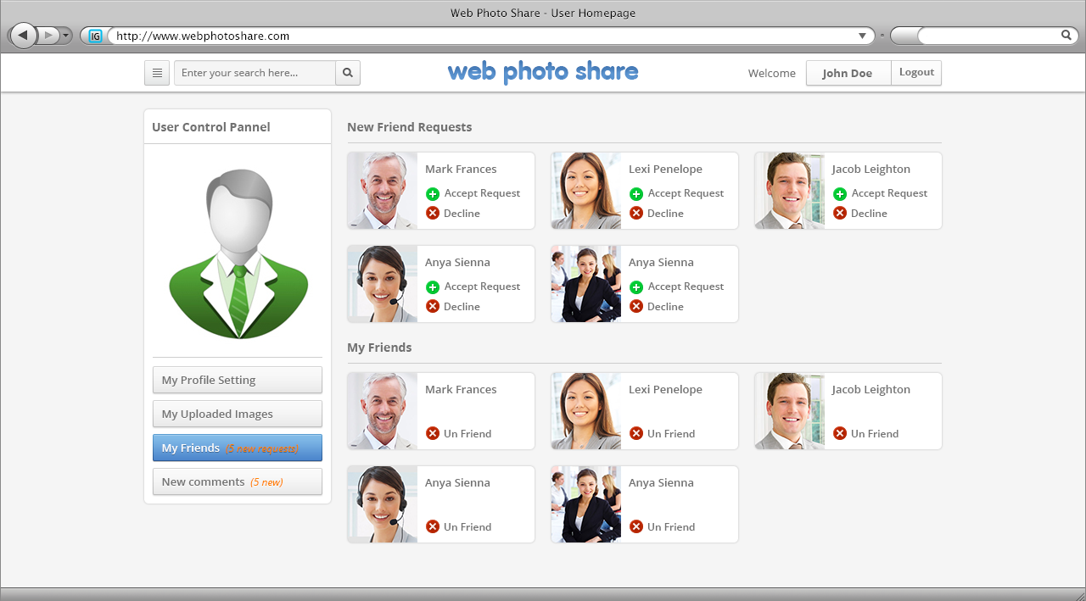

8. User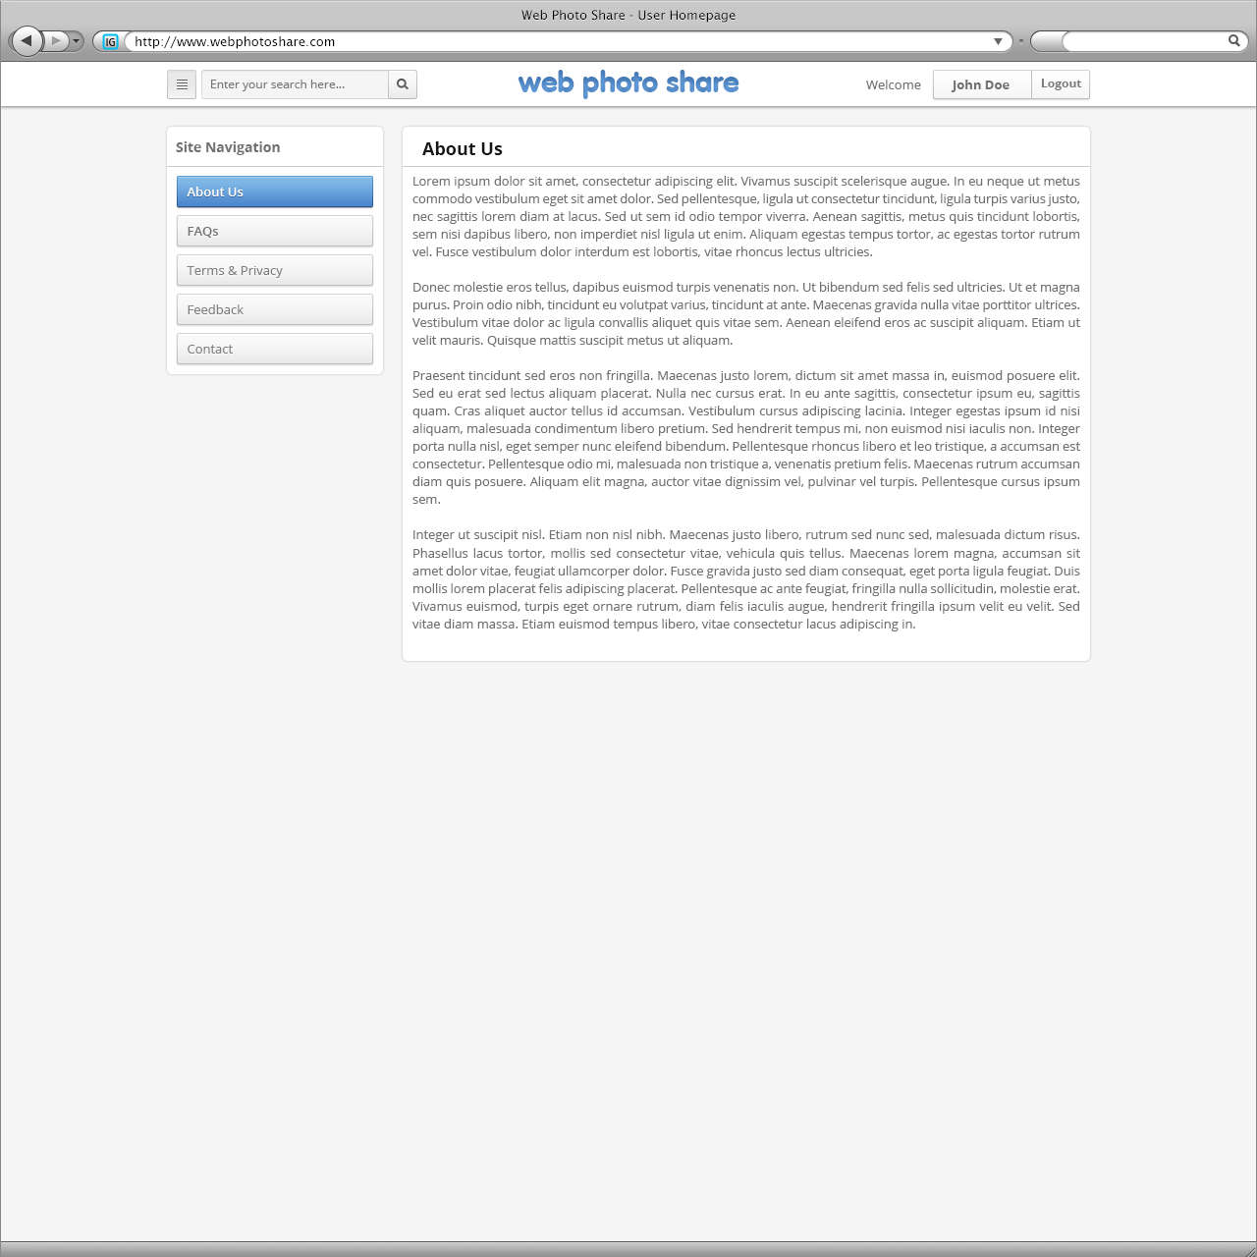

9.Web Photo

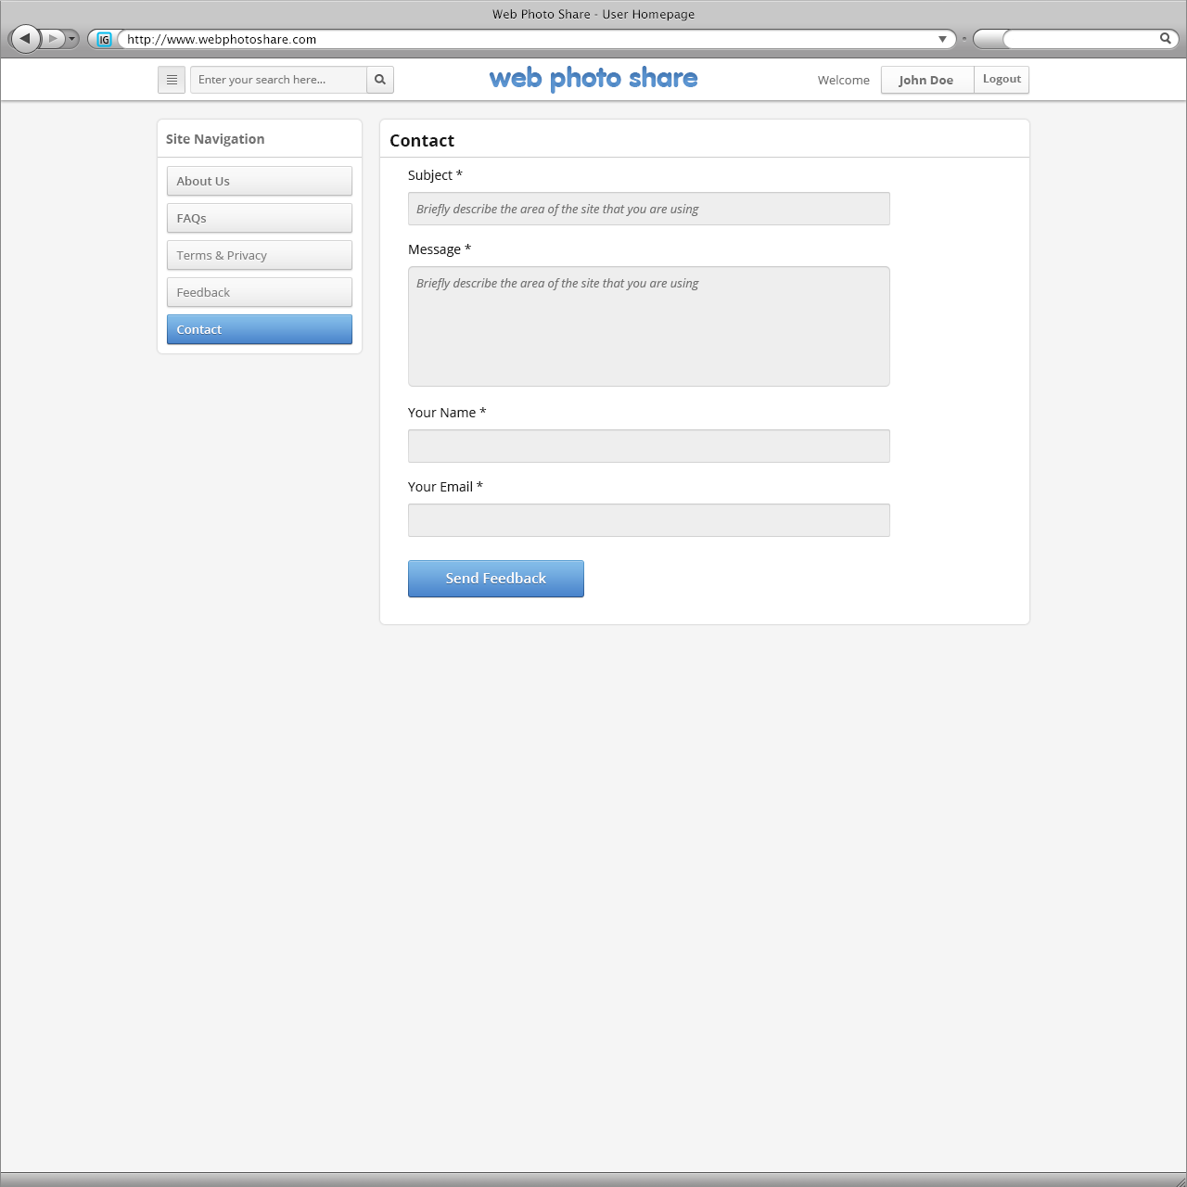

|  |  |  |  |  |  |  |
| --- | --- | --- | --- | --- | --- | --- |
| 1 | txtSub | Textbox | Not null |  | text | Enable |
| 3 | txtMessage | TextBox | notnull | text | text | Enable |
| 4 | txtYourname | Textbox | notnull | text | text | Enable |
| 6 | txtEmails | textBox | notnull | Click | text | Enable |
| 7 | btnSendfacebook | button | notnull | Click | text | Enable |

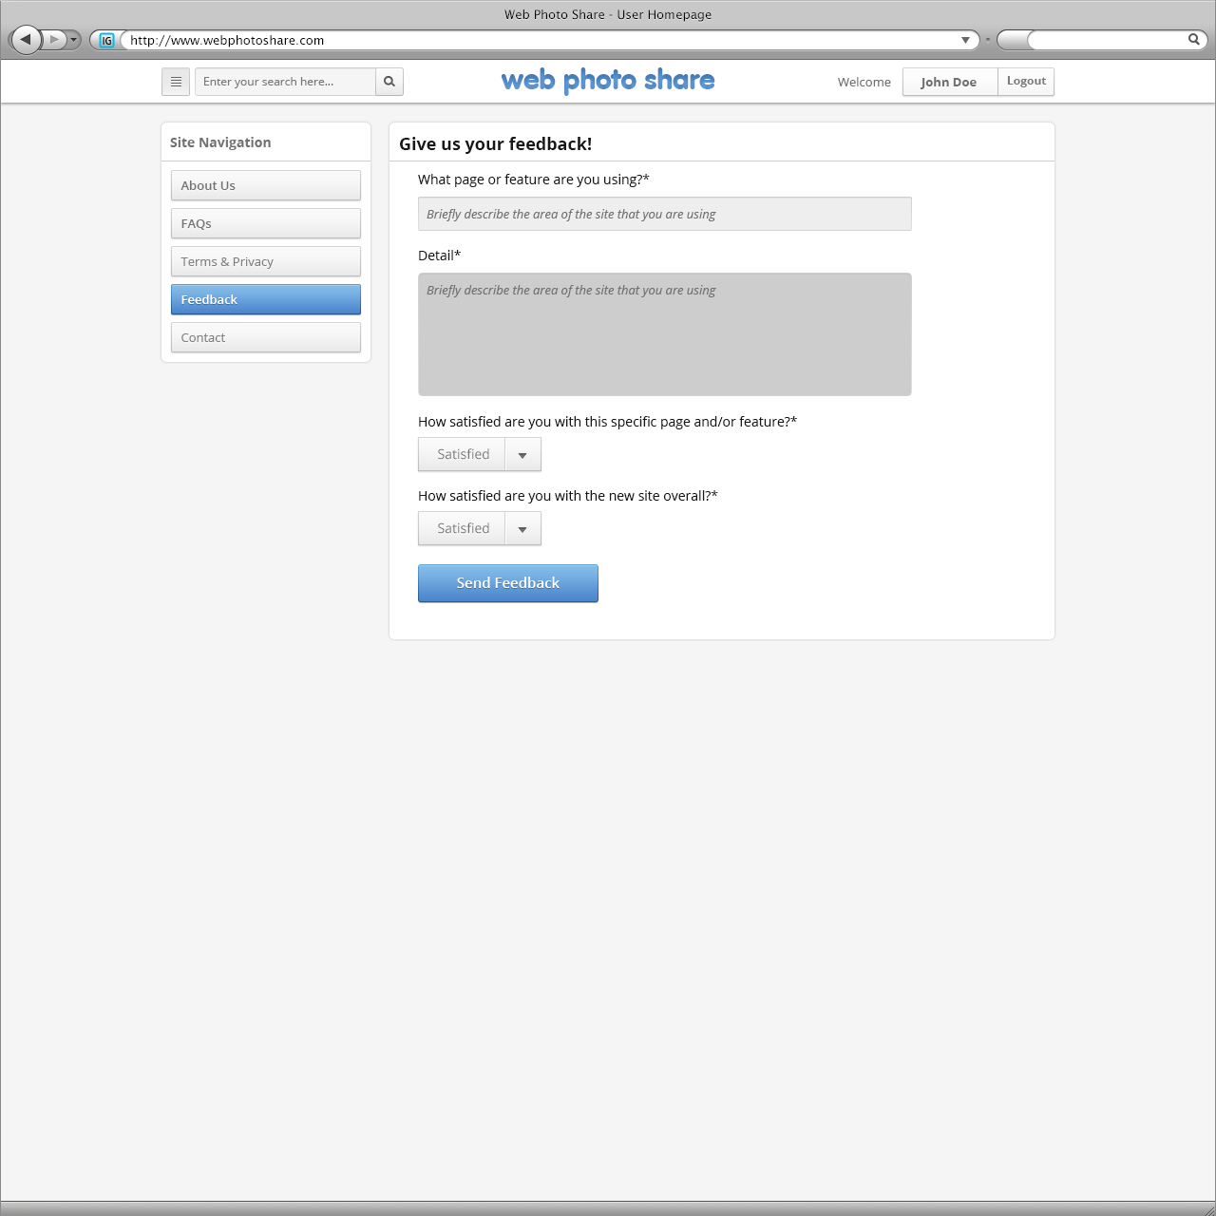

|  |  |  |  |  |  |  |
| --- | --- | --- | --- | --- | --- | --- |
| 1 | txtDescribe | TextBox | notnull | text | text | Enable |
| 2 | txtDetail | Textbox | notnull | text | text | Enable |
| 3 | cboFeature | combobox | notnull | choose | choose | Enable |
| 4 | cboOverall | combobox | notnull | choose | choose | Enable |
| 5 | btnSendfacebook | button |  | Process | Process |  |